Power Quality Improvement Using Interline Unified Power Quality Conditioner

ABSTRACT
Power quality has become an important factor in power systems, for consumer and household appliances with proliferation of various electric/ electronic equipment and computer systems. The main causes of a poor power quality are harmonic currents, poor power factor, supply voltage variations, etc. In recent years the demand for the quality of electric power has been increased rapidly. Power quality problems have received a great attention nowadays because of their impacts on both utilities and customers. Voltage sag, swell, momentary interruption, under voltages, over voltages, noise and harmonics are the most common power quality disturbances.
A new connection for a unified power quality conditioner (UPQC) to improve the power quality of two feeders in a distribution system is proposed. This project illustrates how UPQC can improve the power quality by mitigating all these PQ disturbances. The proposed configuration of the UPQC is developed and verified for various Power Quality disturbances by simulating the model using MATLAB. The disturbances considered here are according to IEC Electromagnetic Compatibility Standards.
In this paper the new connection for UPQC. i.e. INTERLINE UNIFIED POWER QUALITY CONDITIONER (IUPQC) is introduced which is the most sophisticated mitigating device for the power quality disturbances. It was firstly introduced to mitigate the current harmonics and voltage disturbances. The main aim of the IUPQC is to hold the voltages $V_{t1}$ and $V_{t2}$ constant against voltage sag/swell/any power disturbances in either of the feeders. Many contributions were introduced to modify the configurations and the control algorithms to enhance its performance.
Block diagram for proposed system
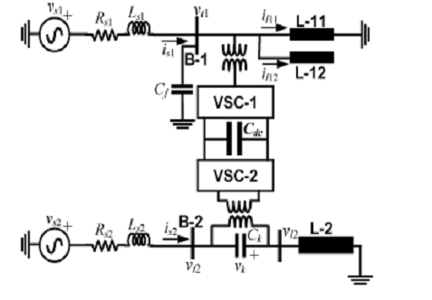
DESIGNG SOFTWARE AND TOOLS:
MATLAB /SIMULATION Software and simpower systems tools are used. Mainly control system tools, power electronics and electrical elements tools are used.

